eCR Now App Configuration Guide

# Introduction:

The guide is provided to help configure the eCR Now App where by it can be used for a single clinical site or multiple clinical sites. The App provides the ability to configure the each EHR’s FHIR Server and appropriate parameters that are required for producing the eICRs. The next section shows the various screens and sample values.

# Accessing the Configuration Screen

The configuration screen can be accessed once the app is launched by going to the URL

http://<localhost:8081>/clientDetails

**Step 1: Access the configuration screen using above URL:**

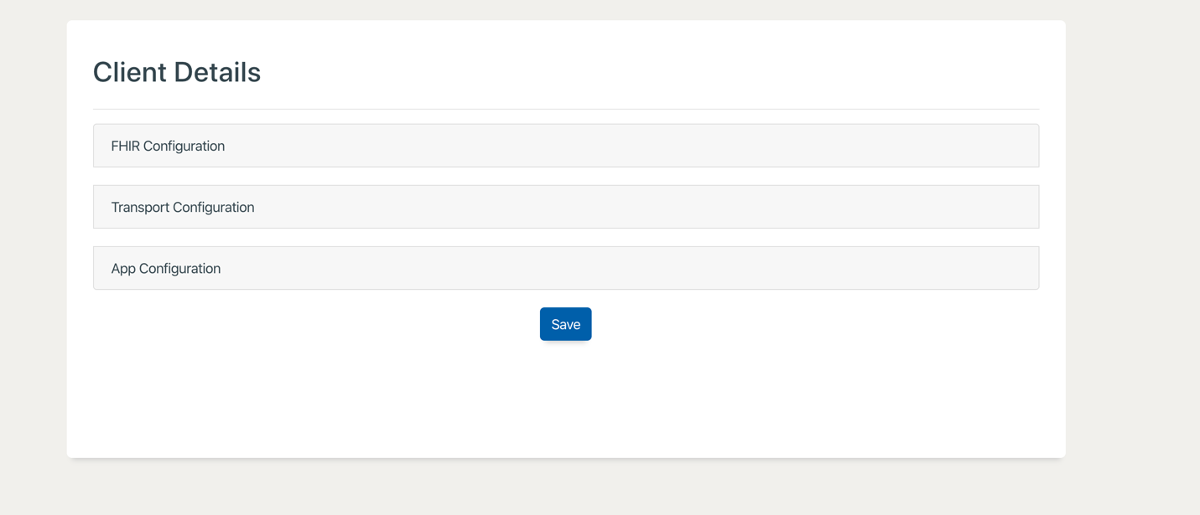

**Step 2: Complete FHIR Configuration**

1. Select Provider or System Account based launch.
   1. Provider Launch is a regular provider facing SMART on FHIR App which uses ehr-launch according to the SMART on FHIR App specification.
   2. System Account launch uses a persistent account to access the FHIR data and is normally triggered by means which does not involve a user. For example from an ADT feed or other mechanisms.
2. Enter the
   1. Client Id
   2. Scopes (Comma Seperated List)
   3. EHR FHIR Server URL
   4. Client Secret (For System Launch only)
   5. Token End Point URL (For System Launch only)

This is shown in the figure below.

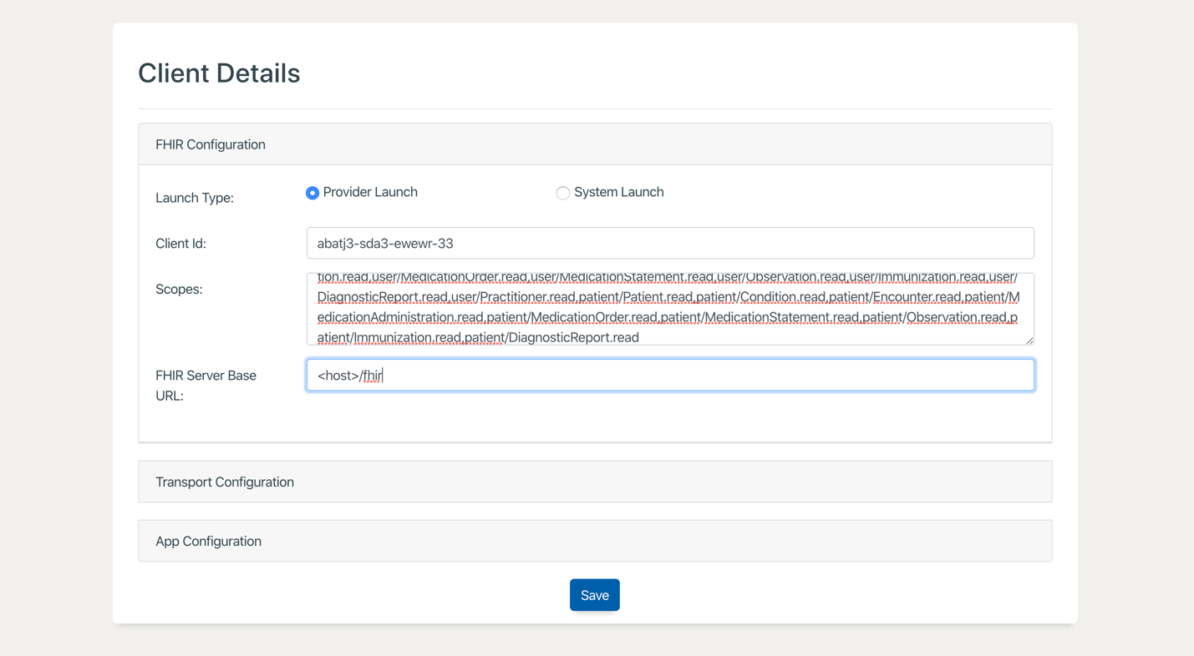

**Scopes for DSTU2:** launch,online_access,offline_access,user/Patient.read,user/Condition.read,user/Encounter.read,user/MedicationAdministration.read,user/MedicationOrder.read,user/MedicationStatement.read,user/Observation.read,user/Immunization.read,user/DiagnosticReport.read,user/Practitioner.read,patient/Patient.read,patient/Condition.read,patient/Encounter.read,patient/MedicationAdministration.read,patient/MedicationOrder.read,patient/MedicationStatement.read,patient/Observation.read,patient/Immunization.read,patient/DiagnosticReport.read

**Scopes for R4:**

launch,online_access,offline_access,user/Patient.read,user/Condition.read,user/Encounter.read,user/MedicationAdministration.read,user/MedicationOrder.read,user/MedicationStatement.read,user/Observation.read,user/Immunization.read,user/DiagnosticReport.read,user/Practitioner.read,user/ServiceRequest.read,patient/Patient.read,patient/Condition.read,patient/Encounter.read,patient/MedicationAdministration.read,patient/MedicationOrder.read,patient/MedicationStatement.read,patient/Observation.read,patient/Immunization.read,patient/DiagnosticReport.read,patient/ServiceRequest.read

**Step 3: Complete Transport Configuration**

The Transport configuration section is to allow the users to specify the type of transport to be used for the specific clinical site. Currently the options are to use

1. Direct
2. XDR.

The configuration parameters for Direct is shown in the figure below.

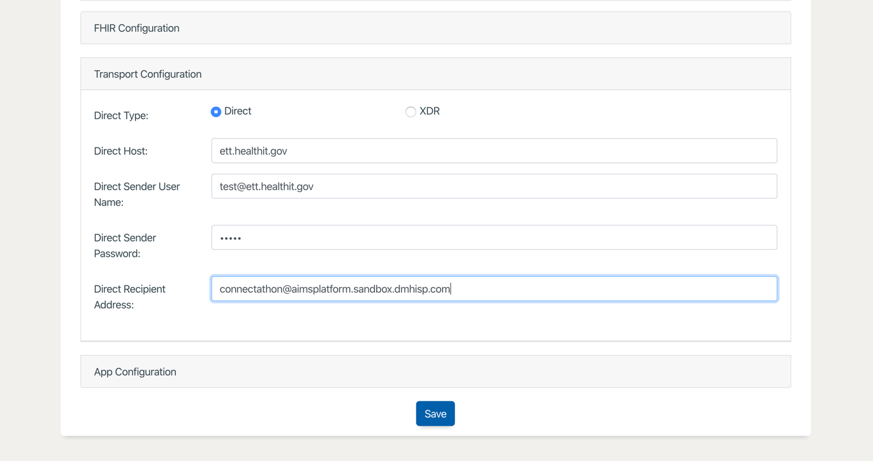

The Transport configuration for XDR is shown below

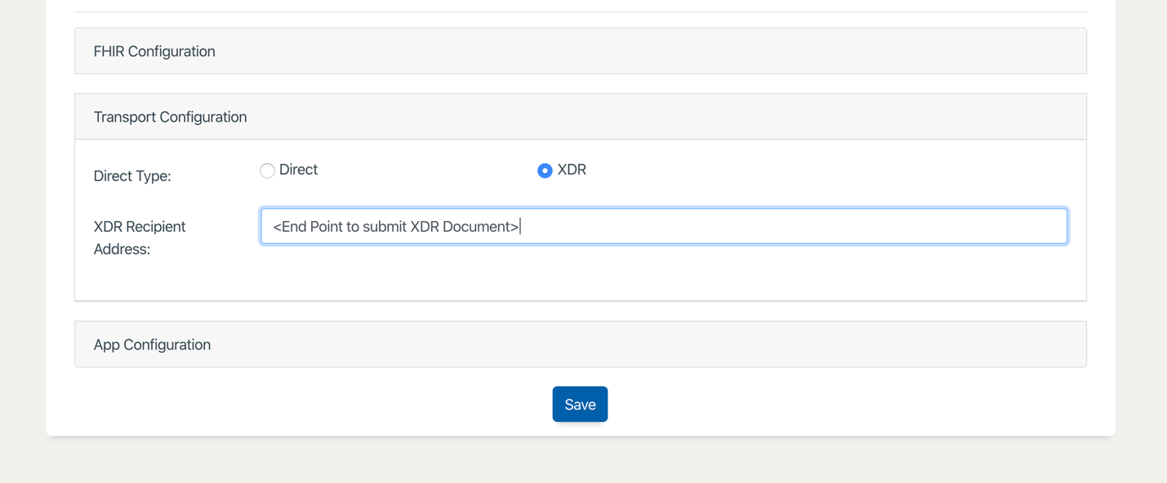

**Step 4: Complete App Configuration**

The final step is to provide app specific details as shown below:

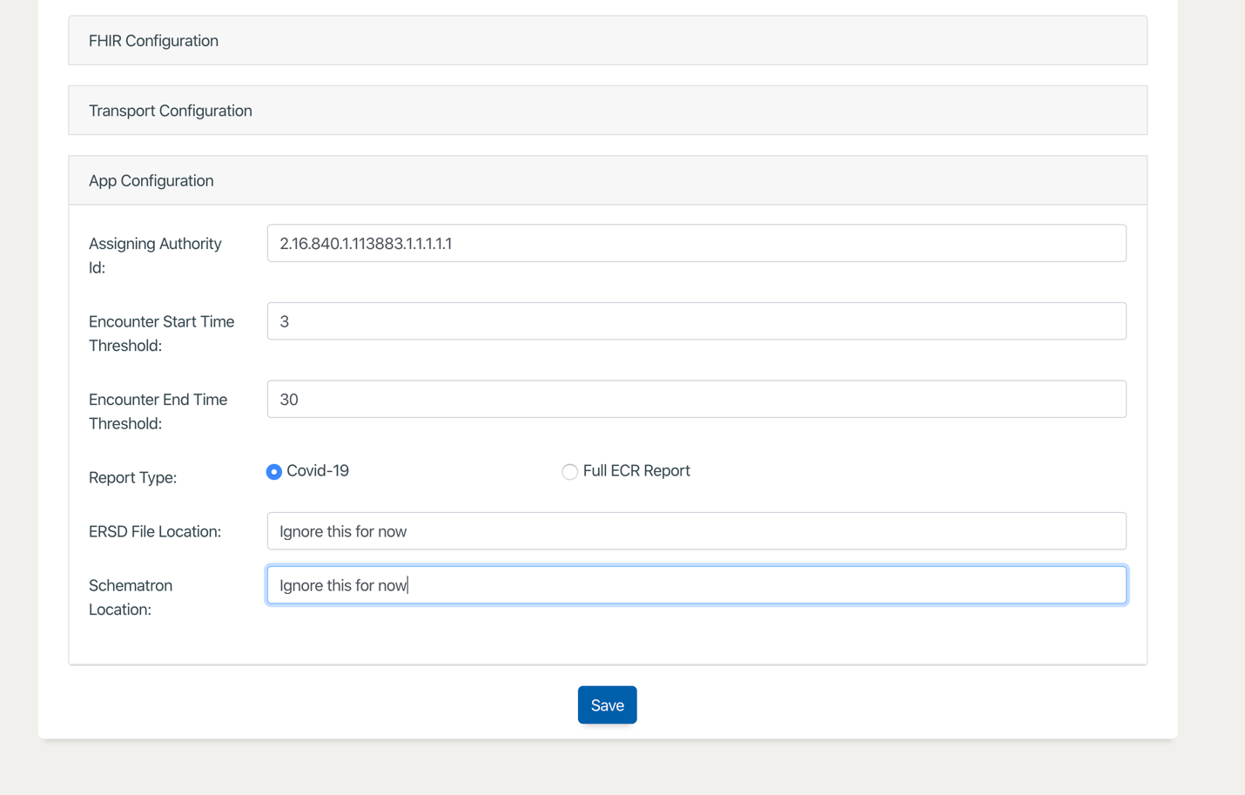

1. Assigning Authority Id
   1. This is being used in the CDA eICR produced as the root element for ids which do not have the System URL populated in the FHIR Resources.
2. Encounter Start and End Threshold
   1. This is a time parameter in terms of hours. This is used to identify the resources relevant for eICR creation when the encounter context is not provided for identifying the specific resources.
      1. For example: A start threshold of 3 means the App will subtract 3 hours from the time the patient context was received by the app.
      2. Similarly an end threshold of 30 means the App will add 30 hours from the time the patient context was received by the app.
      3. During eICR creation, if the encounter context is not provided the App will use the window of time
         1. Patient Launch – 3 hours to Patient Launch + 30 hours to identify the data to be used for eICR reporting.
3. The COVID flag vs Full eCR Reporting is to be used to report on COVID only or full eCR.
   1. For now the App only performs COVID reporting.

**Step 5: Save the App Configuration**

You should receive a success notification and you are ready to start using the app for the specific clinical site.

# Using System Accounts

The section outlines how to use System Accounts and specific Launch APIs to avoid using the regular SMART on FHIR Provider App Launch.

**Configuration Details:**

The Configuration details for the app are very much the same except for entering the System Launch Parameters as shown below.

The scopes to be used will be different, the following is an example.

system/CarePlan.read,system/Condition.read,system/DiagnosticReport.read,system/Encounter.read,system/Immunization.read,system/MedicationAdministration.read,system/MedicationOrder.read,system/MedicationStatement.read,system/Observation.read,system/Patient.read,system/Practitioner.read,system/Procedure.read,system/ProcedureRequest.read

**Token End Point:**

This would be the end point to be used by the app to provide the client id, client secret scopes to get an access token using the System Launch.

**System Launch API:**

Method: POST

URL: http://localhost:8081/api/systemLaunch

RequestBody: {

"fhirServerURL":"https://fhir-ehr-code.cerner.com/dstu2/ec2458f2-1e24-41c8-b71b-0e701af7583d",

"patientId":"12742571",

"encounterId":"97953900"

}

Header: Content-Type: application/json

Response:

StatusCode: 200

Message: Application has been launched succesfully.